Practical No. 9

Creating Restful Web Service in Java

**Q.1]** Write a program to implement the operation that can receive requests and will return a

response in two ways.

1. One - Way operation

2. Request -Response

**Steps with output:**

1. Download derby

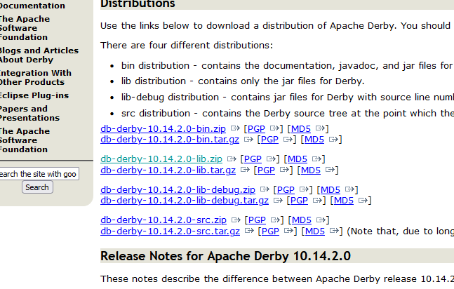

1. Extract it to a location

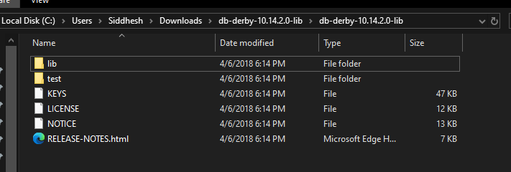

1. In Netbeans, go to services > java DB > right click properties > change the java DB path like following (just cd once)

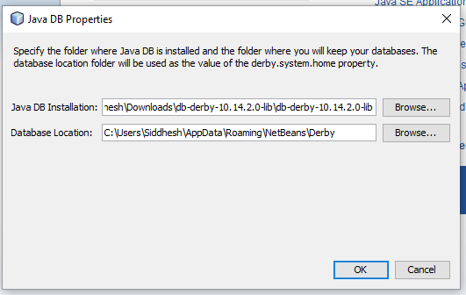

1. Right click “jdbc:derby” and click connect, after connecting “APP” should appear

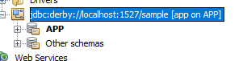

1. Create a new table by right-clicking on Tables and choosing Create Table.

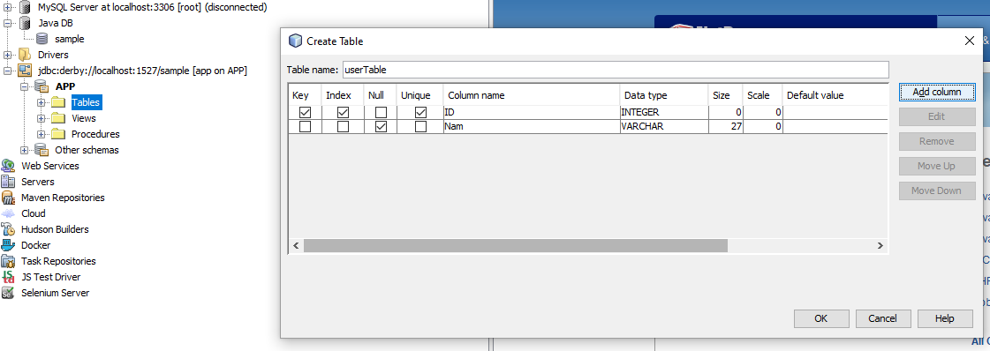

1. Click on the insert records button at the corner of the table view to add the fields using Add Row. Right click user table > view table.

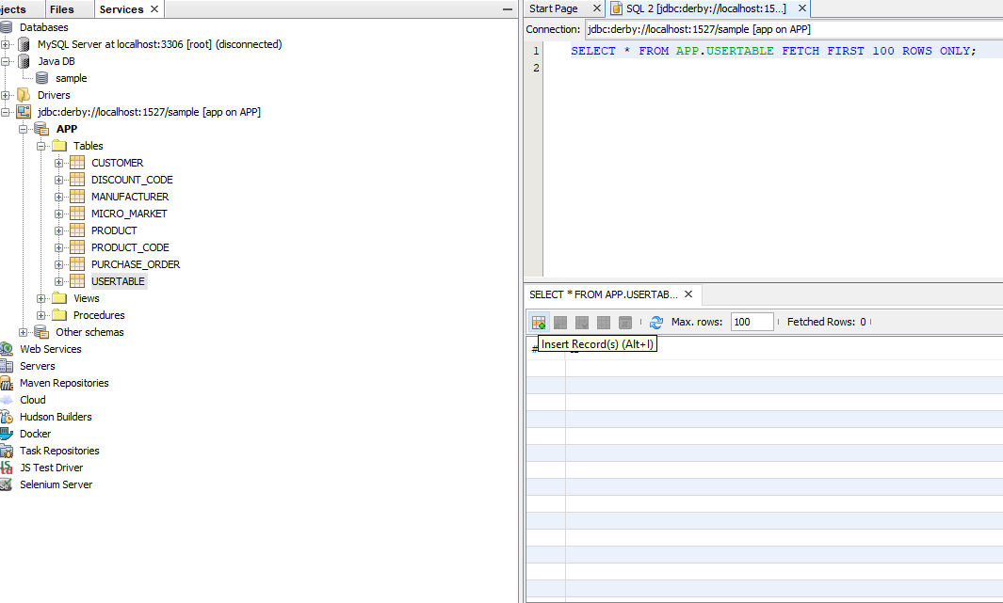

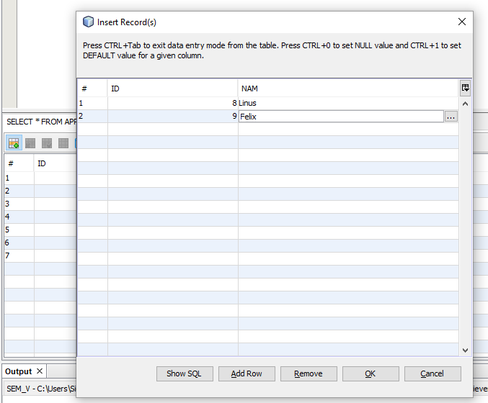

1. Create new Java Web Application Project
2. Right click on the project name and choose New > RESTful Web Services from Database.

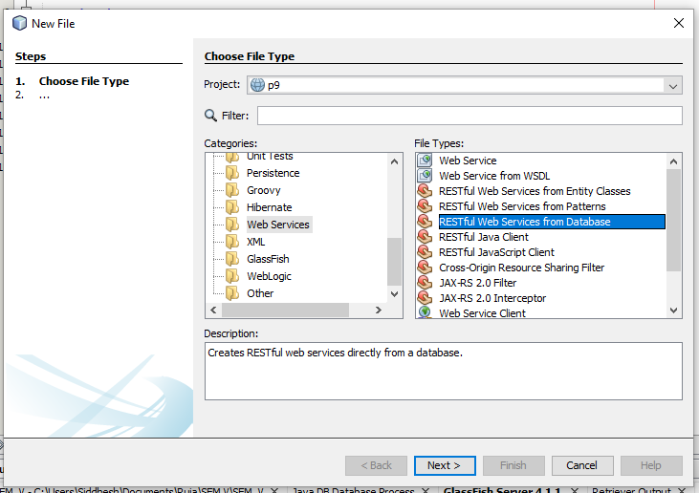

1. Choose the source as jdbc/sample and choose the table. Add the user table to right column

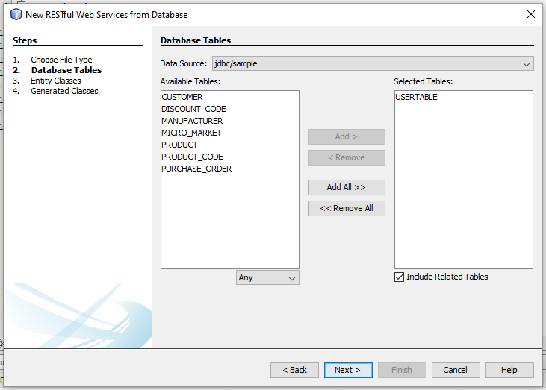

1. Give the package name and finish.
2. The java file for the table will appear in the project directory.

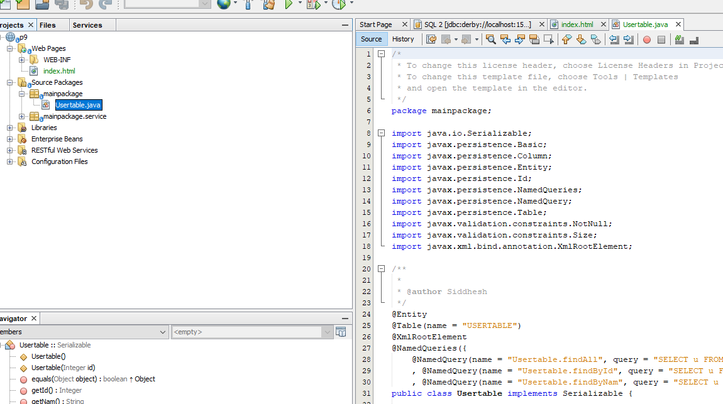

1. Create another Java Web Application Project for client
2. Right client project name > new > RESTful Java client.

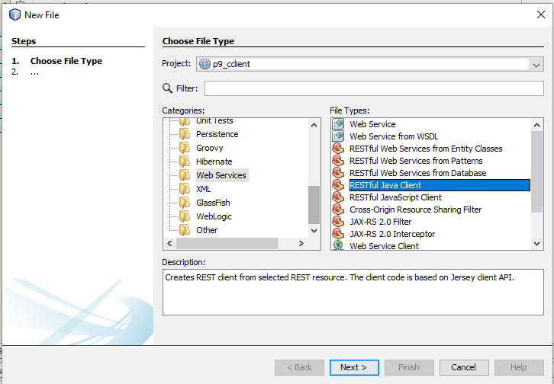

1. Give a name, REST resource and package to the client.

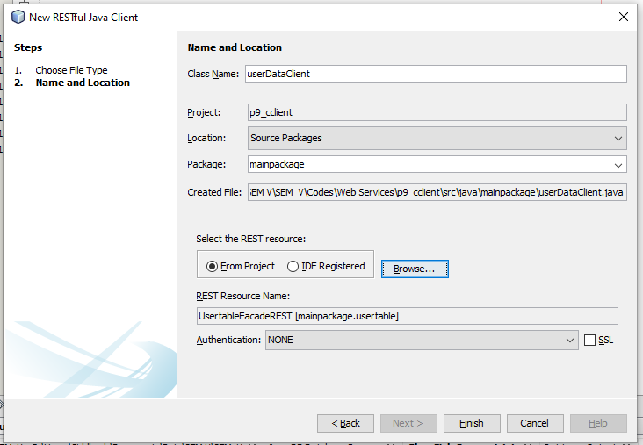

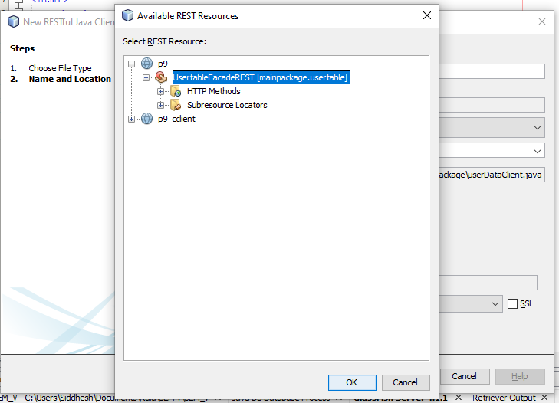

1. Add two JSP files: delData.jsp and getData.jsp by right clicking on the Client project > New > JSP.

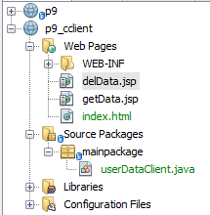

1. Also create a Java class in the client: Right-click > New > Java Client and name it DeleteData

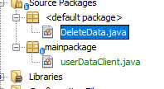

1. Now right click on the Server and choose ‘Test RESTful Web Services’.

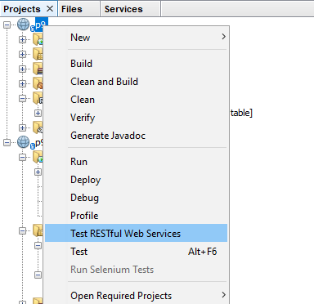

1. A page will open

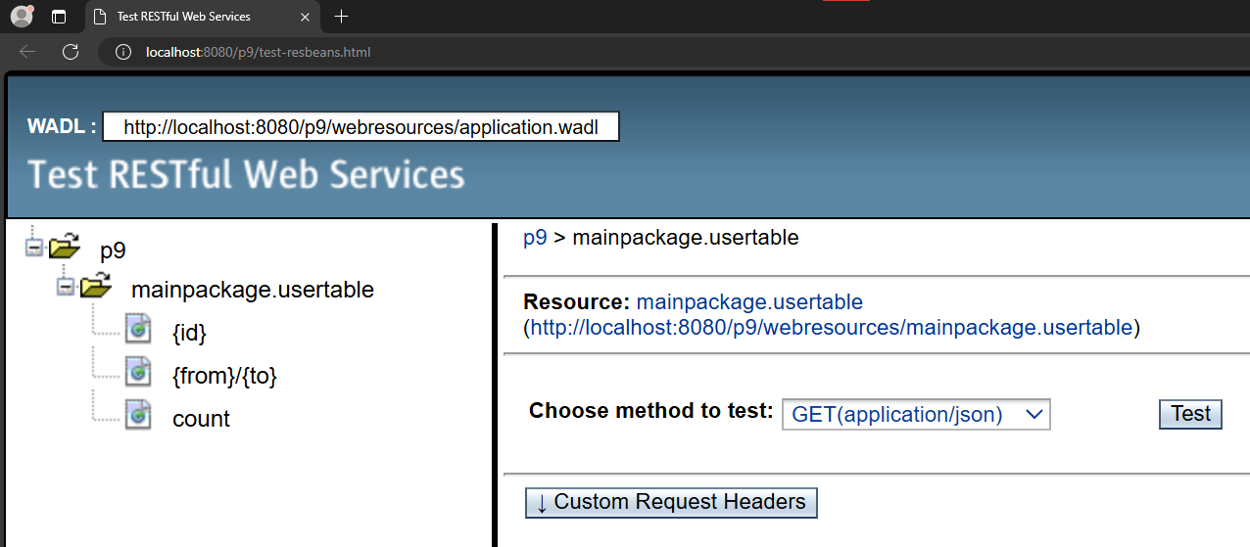

1. copy the URL in the Resource section by clicking “mainpackage.usertable”
2. Add the following contents in index.html (in code section)
3. Add the java codes (in code section)
4. Run the Server first and then the Client (F6)

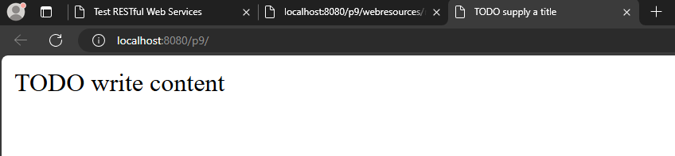

1. Client program

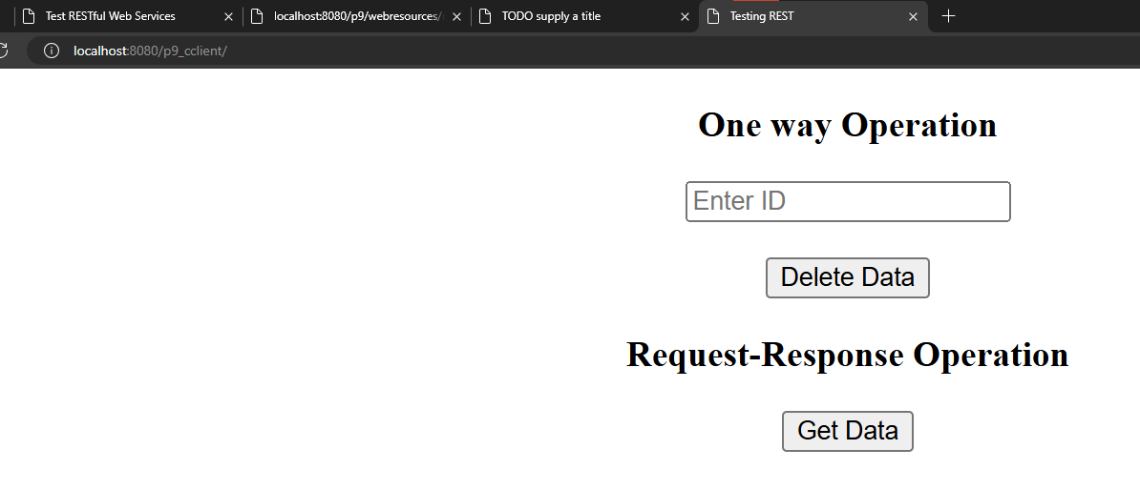

1. Enter an ID to delete and click on Delete Data.

Before

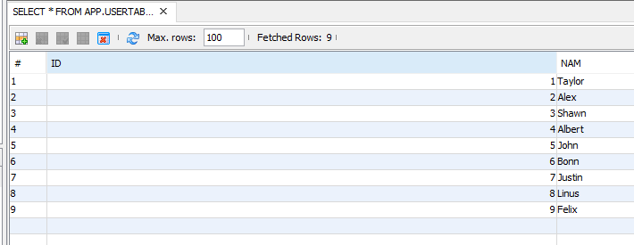

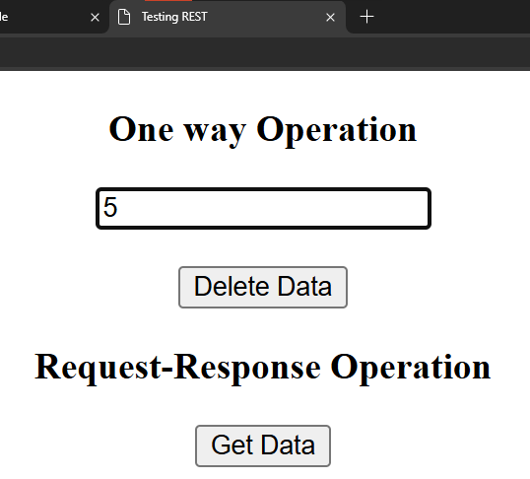

After seeing the table, ID 5 will disappear.

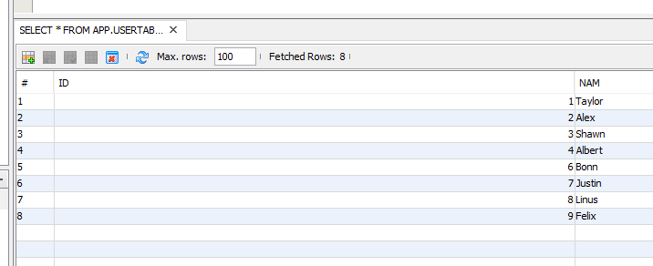

1. Now enter some ID and click on Get Data.

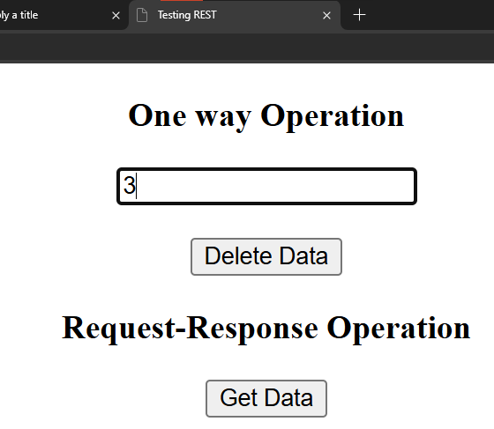

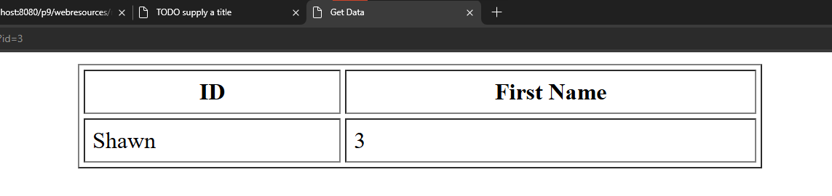

**Codes**

**[getData.jsp]:**

<%--

Document : getData

Created on : Sep 4, 2024, 9:34:36 PM

Author : Siddhesh

--%>

<%@page contentType="text/html" pageEncoding="UTF-8"%>

<!DOCTYPE html>

<html>

<head>

<meta http-equiv="Content-Type" content="text/html; charset=UTF-8">

<title>Get Data</title>

<script>

//take id from request to display data

<% String id_str = request.getParameter("id"); %>

var id = <%=id_str%>

var request =new XMLHttpRequest();

request.open('GET','http://localhost:8080/p9/webresources/mainpackage.usertable'

);

request.onload=function()

{

var parser = new DOMParser();

var xmlDoc = parser.parseFromString(this.response,"text/xml");

var x=xmlDoc.getElementsByTagName("usertable");

console.log(x);

console.log(id);

//for displaying only required id data

var table=document.getElementById("myTable");

var row=table.insertRow(-1);

var cell1=row.insertCell(0);

var cell2=row.insertCell(1);

console.log(xmlDoc.getElementsByTagName("usertable")[id-

1].childNodes[0].firstChild.nodeValue)

cell1.innerHTML=xmlDoc.getElementsByTagName("usertable")[id-

1].childNodes[1].firstChild.nodeValue;

cell2.innerHTML=xmlDoc.getElementsByTagName("usertable")[id-

1].childNodes[0].firstChild.nodeValue;

};

request.send();

</script>

</head>

<body>

<center>

<table id="myTable" border="1" cellpadding="5" cellspacing="3"

width="50%">

<tr>

<th>ID</th>

<th>First Name</th>

</tr>

</table>

</center>

</body>

</html>

**[delData.jsp]:**

<%--

Document : delData

Created on : Sep 4, 2024, 9:34:46 PM

Author : Siddhesh

--%>

<%@page contentType="text/html" pageEncoding="UTF-8"%>

<!DOCTYPE html>

<html>

<head>

<meta http-equiv="Content-Type" content="text/html; charset=UTF-8">

<title>Delete data</title>

</head>

<body>

<%@page import="mainpackage.DeleteData"%>

<%

String id = request.getParameter("id");

DeleteData.deldata(id);

%>

</body>

</html>

**[DeleteData.java]:**

package mainpackage;

/*

* To change this license header, choose License Headers in Project Properties.

* To change this template file, choose Tools | Templates

* and open the template in the editor.

*/

/**

*

* @author Siddhesh

*/

public class DeleteData {

public static void deldata(String id)

{

String a=id;

userDataClient ob=new userDataClient();

ob.remove(a);

//System.out.println("Data is deleted");

}

}

**[index.html]:**

<!DOCTYPE html>

<!--

To change this license header, choose License Headers in Project Properties.

To change this template file, choose Tools | Templates

and open the template in the editor.

-->

<html>

<head>

<title>Testing REST</title>

<meta charset="UTF-8">

<meta name="viewport" content="width=device-width, initial-scale=1.0">

</head>

<body>

<center>

<form>

<h3>One way Operation</h3>

<input type="text" name="id" placeholder="Enter ID"><br><br>

<input type="submit" formaction="delData.jsp" value="Delete Data"><br>

<h3>Request-Response Operation</h3>

<input type="submit" formaction="getData.jsp" value="Get Data">

</form>

</center>

</body>

</html>

**Q.2]** Repeat the above question but for the employee table.

**Steps:**

1. Repeat the same steps above exactly
2. 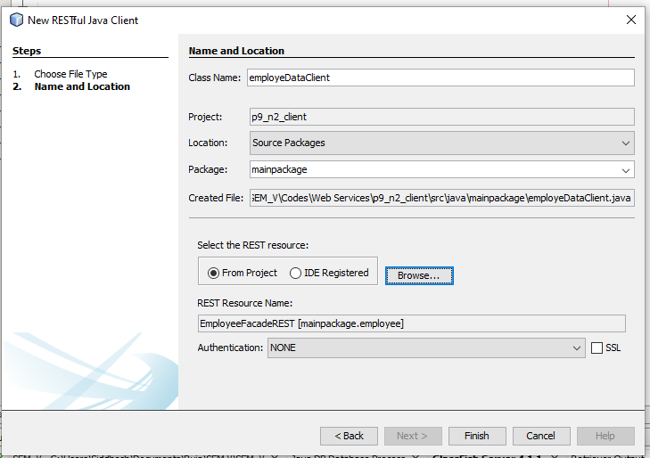
3. Add the three files in code section in client project
4. Run both the projects

**Table:**

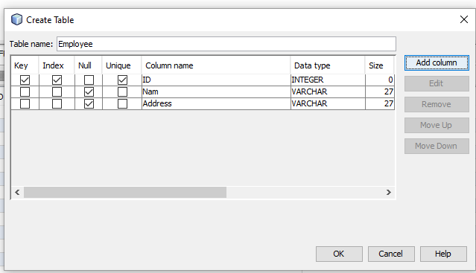

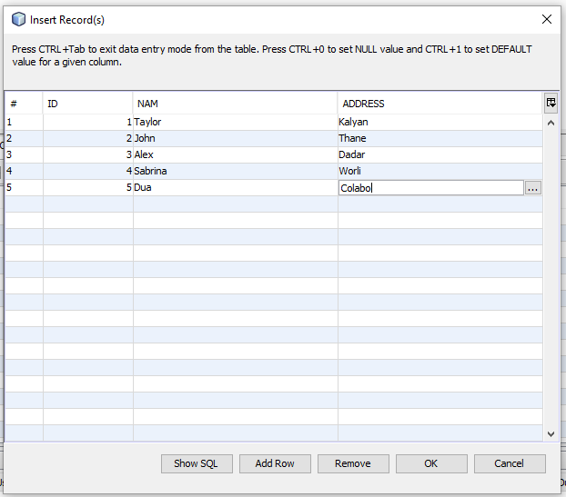

**Codes**

**[delData.jsp]:**

<%--

Document : delData

Created on : Sep 4, 2024, 10:14:51 PM

Author : Siddhesh

--%>

<%@page contentType="text/html" pageEncoding="UTF-8"%>

<!DOCTYPE html>

<html>

<head>

<meta http-equiv="Content-Type" content="text/html; charset=UTF-8">

<title>JSP Page</title>

</head>

<body>

<%@page import="mainpackage.DeleteData"%>

<%

String jspId = request.getParameter("id");

DeleteData.deleteDataOperation(jspId);

%>

</body>

</html>

**[index.jsp]:**

<!DOCTYPE html>

<!--

To change this license header, choose License Headers in Project Properties.

To change this template file, choose Tools | Templates

and open the template in the editor.

-->

<html>

<head>

<title>TODO supply a title</title>

<meta charset="UTF-8">

<meta name="viewport" content="width=device-width, initial-scale=1.0">

</head>

<body>

<form>

<h2>One way operation</h2>

<h3>Enter ID to delete data: </h3>

<input type="text" name="id" placeholder="Enter ID"><br><br>

<input type="submit" formaction="delData.jsp" value="Delete Data"><br>

</form>

</body>

</html>

**[DeleteData.java]:**

/*

* To change this license header, choose License Headers in Project Properties.

* To change this template file, choose Tools | Templates

* and open the template in the editor.

*/

package mainpackage;

/**

*

* @author Siddhesh

*/

public class DeleteData {

public static void deleteDataOperation(String id){

employeDataClient client = new employeDataClient();

client.remove(id);

}

}

**Output:**

Before deleting

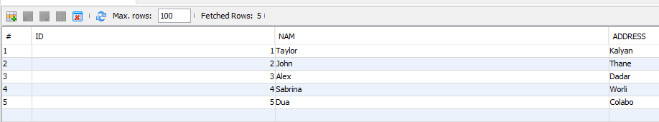

Entering a ID to delete

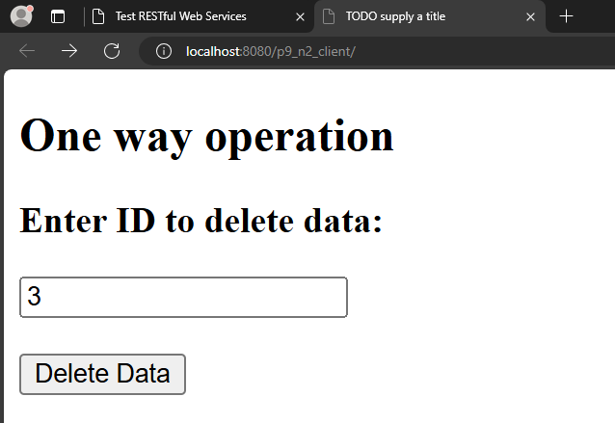

After deleting

